The Sacrament of the Eucalypt
Symbol of the Tree of Life

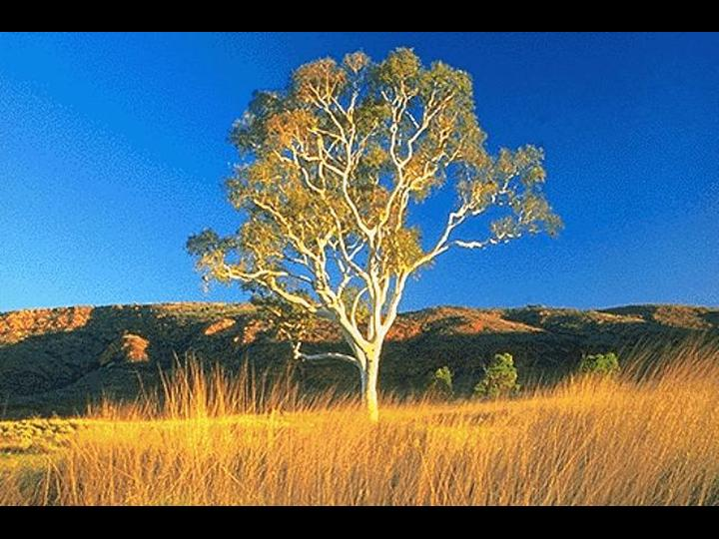

“All the trees of the forest sing for joy” Ps.96.12

We worship this Sunday with the bush in the bush.
The church becomes the bush, filled with native plants with eucalypt branches draped over the altar. At the center of the church or sanctuary a large eucalypt may be placed to represent the tree of life. This liturgy is appropriate for Fauna and Flora or Forest Sunday

Invocation

Leader In the name of the Creator, the fountain of life,
the name of Christ, the pulse of life,
and the name of the Spirit, the breath of life. Amen.

People Holy! Holy! Holy!
Earth is filled with God’s presence.

L Christ, we come to into your presence, today,
to worship in a sanctuary of Earth called the bush.

P A planet shimmering with your presence,
a presence quivering in the bush,
a presence vibrating in the fauna,
a presence pulsating in the flora.

L God, reveal yourself to us in this place,
and show us your face in all creation.

P. Holy! Holy! Holy!
The bush is filled with God’s presence.

Invitation/Call to Worship
(Leaders may call fauna and flora to worship from different points in the place of worship.)

L We invite the forests to worship with us.

P Mountain ash and eucalypts,
quivering ferns and glistening moss!

L We invite tall trees to celebrate life.

P To lift green leaves in the breeze
and sing their oxygen into the air.

L We invite the night life of the bush to sing.

P Green tree frogs and timid moths,
butterflies and swirling bats!

L We join with the fauna of the bush in praising God.

P Lyre birds and black cockatoos,
platypus, pythons and butterflies.

L We celebrate the song of the forest!

P Sing! Forest! Sing!

Procession and Song
(Worship leaders process into the church with native plants; the fauna join us in celebration. The flora are held aloft and placed around the tree of life at the center of the sanctuary).

O For a Thousand Trees
Words: Norman Habel

O for a thousand trees to sing
And join with is this day,
With ferns and frogs and butterflies:
A forest hymn of praise.

Come celebrate with all the bush,
Let species rare begin,
With geese and owls and cockatoos:
A choir of country kin.

How can we hear creation groan,
The outback cry in pain?
With desert dragons we rejoice
When Earth is born again.

Let ev’ry stream and river flow
In song towards the sea;
With whale and seal and albatross,
We thank God we are free.

O for eucalypts to sing
And join with is this day,
With all the creatures of the bush,
A forest hymn of praise.

Confession

L We remember:

P We remember birds and animals we have loved
and with whom we feel a special kinship.

We remember the gardens we cherished
and the bush where we played in our childhood.

L We confess:

P We have become alienated from Earth,
and treated this garden called Earth
as a beast to be tamed,
as a domain to be dominated
and a place to be ruled for our gain.

L We confess:

P We have polluted our garden planet.
We are sorry.
We have ignored the distant sounds in the bush,
the sound of chain saws clearing for greed and gain,
the sound of old eucalypts falling forever,
the sound of rare species breathing their last.
We are sorry. We are sorry.

Absolution

L Christ hears your confession from the cross,
forgives your sins against the bush,
and calls you now to open your ears and your hearts
to sustain rather than destroy our eucalypts,
the trees God has planted for life and wonder.

P Christ, teach us to love Earth as our home
and all living creatures as our kin.
Help us to return home to Earth.

L. I speak for Christ:
I invite you to come home to Earth
and call you to tend this planet with love,
to nurture the bush as I have nurtured you
and to join me in healing creation.

P Shalom! Shalom!
We are coming home!

Collect/Prayer for the Day

P. God, our Creator, whose presence fills our planet, help us to discern your vibrant presence among us and our kin in creation, especially in the mysteries of the bush. Help us to empathise with your creatures who are suffering and to serve you as agents for healing your creation. In the name of Christ who reconciles and restores all things in creation. Amen.

Readings
for Fauna and Flora Sunday

Old Testament Job 39.1-12, 26-30

God shows Job the world of the wild, over which he as a human has no control, but where God’s Wisdom and nurture are ever present.

Epistle Acts 17.22-28

In his famous sermon about the ‘Unknown God’, Paul claims that God created all humans with the same breath and inner impulse to search for God’s presence.

Gospel Luke 12.22-31

The reign of God and the world of the wild complement each other, says Jesus. God provides for all and that should lead us to live in harmony with all of nature.

Sermon or Reflection: The Tree of Life

Refrain – Reflection

(After each verse of the refrain we pause to reflect silently on God’s close presence in creation, especially in the bush with eucalypts. These interludes may include soft music, silence, or sounds of the bush.)

Be still and feel the presence of God,
the presence pulsing, pulsing through Earth,
be still and feel the pulse of God.

(Interlude)

Be still and hear the Spirit of God,
the Spirit breathing, breathing through Earth,
be still and hear the breath of God.

(Interlude)

Be still, discern the Wisdom of God,
the wisdom guiding, guiding this Earth.
be still, discern the Wisdom of God.

Melody: Be Still and Know That I am God
Words: Norman C Habel

Offering and Offering Prayer

- God, our Creator, through your love you have given us these gifts to share. Accept our offerings as an expression of our deep thanks and signs of our concern for those in need, including our fellow creatures on planet Earth.

P. With all creation, we bless our Creator.

Prayers of the People

Song

The Sacrament of the Eucalypt

(The eucalyptus tree in the sanctuary represents the tree of life. Clusters of fresh eucalyptus leaves located on the altar are blessings of life we receive today from the tree of life, the ultimate gift from our Creator.)

L The Creator be with you and all creation.

P And also with you.

L Open your hearts.

P We open them to the Source of all Life

L Let us give thanks to our Creator.

P It is right to join all fauna and flora in thanking God.

L It is right to give you thanks, loving Creator.
Your Spirit is the impulse for all things to be,
for space, stars and stardust to appear,
for Earth to emerge from the deep,
for life to be born of Earth and
for humans to be born of Earth and the Spirit.

Your Spirit was the life impulse in all things,
renewing the barren and healing the wounded,
groaning in anticipation of a new creation,
stirring a new life born of water and the Spirit.

Your presence is the living impulse in all things,
the Christ deep among us,
filling Earth—land, sea and air;
filling the eucalypt with the pulse,
the breath and the aroma of life.

Therefore with ancient voices in the forest,
and all the creatures of the bush,
we proclaim your presence among us.

P Holy, holy, holy, God of all life,
Fill our lives with life today.

Invitation to Celebrate

L Come, for all things are now ready.

Come to the table with all your kin.

Come and receive eucalyptus leaves

from branches of the tree of life.

(Worshippers come to the altar, receive a handful of eucalyptus leaves and return to their seats where they may contemplate the gift they have received.)

L Take the leaves from the tree of life

and crush them with your fingers and reflect. (Pause and reflect)

Raise the leaves toward your face

and hear a life-giving message

from the Source of Life:

Take and feel the pulse of life

linking you now

with the deep Pulse of all life. (Pause and reflect)

Take and breathe the aroma of life

linking you now

with all your kin in the Tree of Life (Pause and reflect)

Take and inhale the breath of life

linking you now

with the Spirit, the breath of God (Pause and reflect)

P May we who share these gifts,
the pulse of life, the aroma of life
and the breath of life
with one another and all our kin.

Passing the Peace/ the Gift of Life

Closing Blessing

L Now may the pulse of life beat within your body, the aroma of life stir your soul and the breath of life lift your spirit. In the name of the Creator. Amen

Closing Song: Sing with the Sun
C. 2008 Noman Habel
Melody: Christ is Alive

Sing with the sun, the king above,
Assigned by God to rule the skies,
Dispensing justice with the light
On rich and poor, on fools and wise.

Join with a choir of finch and dove,
Sing praises for the rising sun,
All celebrating with the dawn,
The presence of the Risen One.

Sing with the sun whose burning fire
Surrounds our God when high above,
But reaches humans far below
In golden streams of warmth and love.

Sing with the ferns and forest fronds,
Accepting light that keeps leaves green,
Imploring God to now make sure
That humans keep this planet clean.

Join with our kin the kangaroo
Who dine in peace as suns turn red,
And share with them and Christ our Lord
The gift of life and breaking bread.

Sing with the sun in light-year time,
Exploding in from outer space,
A blazing gift from God on high
That once broke through in Jesus’ face.

